

**WELCOME TO THE 6th Annual**

**SAN ANTONIO REGIONAL SCIENCE OLYMPIAD!!**

**2017**

Thank you for coming, we are so happy you all are here today and we look forward to a continued relationship with your school teams! The Biology Club, Pre-Health Club and Math Club and the program of Biology here at Texas A & M – San Antonio have sponsored much of this event and many of our students are volunteers. We hope you all have a great time today! **Director**: Megan Wise de Valdez **Co- Directors**: Jessica Adams and Amanda Gordon

**TOURNAMENT FORMAT**

**REGISTRATION BEGINS – 7:00AM and will run through 8:00AM**

**IMPOUND BEGINS – 7:00 AM and runs through 7:45 AM –** Only two events require impound: Wind Power and Roller Coaster – the impound room is 401 (4th floor of the CAB building – see maps)

**BUILD EVENTS** – sign-up for time slots are currently on-line. There are two events that are unique: Wind Power & Mission Possible - ALL participants must arrive at the start time of the event to a) take the exam at the same time (Wind Power) b) set-up their devices for 30 minutes. AFTERWHICH they will test their devices in their on-line sign up designated slots.

The 2017 San Antonio Regional Science Olympiad competition will consist of 18 different events for the B-division and 18 different events for the C-division. These events were selected by National Science Olympiad and the Texas Science Olympiad. Each school team will compete in all of the events for their division. All events are weighted equally.

**BEHAVIOR/CONDUCT** – The purpose of the Science Olympiad is to improve student interest in science, develop teamwork and cooperation and most of all to have fun – winning is a bonus. To ensure that this remains the goal of all involved we have written a “Team Policy” that all team members and coaches must sign and bring to competition day. But as a reminder:

Adults: please be aware that any of the following behaviors by you, your team, or anyone associated with your team will result in the disqualification of your team for this competition:

1. Rude or abusive behavior toward any staff member of volunteer
2. Disruption of any event or the awards ceremony
3. Cheating or instructing team members to cheat.
4. Violation of Campus Construction policy: no one is allowed on or near construction zones.

**FACILITIES** – Events will be held in the Central Academic building (the one with the dome), the adjacent auditorium, and the Senator Frank Madla Building of Texas A & M-San Antonio. Because A&M-San Antonio holds courses on Saturdays at our main campus we ask that students and coaches respect the access of the A&M-San Antonio students to their classes.

Home-bases will be more like the ‘camp city’ seen at the State event in College Station where each team chooses an area to call their home base. We have outlined where on campus home bases will be allowed to set up (see maps below).

**FOOD** – The campus food service is not open on Saturdays. Please be prepared to bring your own food and snacks. We have vending machines – make sure to bring your own cash/coins.

**PROTOCOL FOR EVENTS**

1. Parents, coaches, and observers are allowed in designated viewing areas and NOT ALLOWED in the actual competition areas.
2. Competitors only are allowed on event floors to access their event rooms but NO LOITERING outside of the events or in the halls. A) this potentially can lead to violation of SO rules and B) will disrupt university classes that are being held.
3. Teams must arrive at their event room no earlier than 5 minutes before the start of their event (see NO LOITERING RULE) .
4. Teams cannot enter until the event coordinator has let them in. If arriving late, students will be allowed in, but will not be given additional time.
5. If a competitor must leave a competition area for any reason, he/she must turn in all work and may not return to that event (i.e. go to the bathroom before).
6. Cell phones, pagers, laptops, PDA’s two-way radios, (ANY communication device) are NOT ALLOWED in the competition areas. Contestants having these devices in the competition area or other forbidden books or materials will be disqualified

REMINDERS:

1. There will be some Saturday classes being held on the second and third floor, please be mindful of this and keep noise levels to a minimum.
2. The University Library is OFF LIMITS to teams, coaches, chaperones and family members– classes are still being held on campus and this space is reserved for those students.
3. **Obey posted signs.**
4. Pick up all trash – leave a clean “home base”.
5. Bring your own food and beverages as the school cafeteria will not be open on Saturday.
6. Be prepared for outdoor weather as home-bases are most convenient outdoors.
7. No closed tents, only shade-providing canopy tents
8. No grills or electric burners.

**WEB ACCESS –** Please see directions on our A&M Science Olympiad Page (a .pdf document).

**SAFETY –** On the website on the homepage you will find a link to the presentation of our building safety orientation. Please take a few minutes to familiarize yourself with this presentation in the event that one of the emergency situations arise.

**PARKING** – All teams and associated support people will be asked to park in the student parking lot on the west side of the building. When coming down University Way, you will turn right and then a left to access the student parking lot. Please use common sense when parking large vehicles; it will be best if large buses or vans park in the least-occupied areas of the parking lot.

**TEAM MEMBER WRISTBANDS** – Wristbands are provided at check-in for each team member. Wristbands must be worn for the entire competition. If a substitution is needed the team member that needs to be replaced must relinquish his/her wristband. Only two replacement wristbands (the number of substitutes allowed) will be issued to a team.

**TEAM SUBSTITUTES** – additional participants (2 per team) are allowed to substitute in case of a bona fide emergency or for an ill team member ONLY. In the vent that a team member is ill, that team member must relinquish his/her wristband and a replacement wristband will be provided to the substitute team member. The ill team member will not be allowed to return to the tournament.

**APPEALS PROCEDURE** – Contestants who believe that other participants are breaking rules (using forbidden books or materials, using a cell phone, pager, or PDA, etc.) should report this immediately to the event coordinator who will immediately render a decision regarding the legality of the activity. No other appeal related to this situation should be necessary.

An appeal is not a complaint. Complaints should be written (no form exists) and be clearly labeled as a complaint and turned in to the help desk attendant.

If a team makes a FRIVILOUS APPEAL, this will result in adding 1 point to the overall team score.

**SCORING** – Each team must compete in all event offered in their division. In each division (B or C), the total number of teams, which we’ll call *n*, will be used to determine the points a team receives in an event. Each team ranked in the event will receive the number of points equal to its rank. First place will receive one point, second, two, third, three, etc… (Tie-breaking procedures in each event will prevent ties). A team that makes an honest attempt to participate, but that cannot be assigned a raw score because of time, mechanical failure, wrong dimensions, etc., will be ranked with participation points (P) on the score sheet, which will be *n* points.

A team that is a No-Show (NS) will be given *n*+1 points. A team that is disqualified (DQ) for behavior problems, poor sportsmanship, or as provided in the event rules will be given *n*+2 points.

These scoring rules apply to each event, regardless of the number of teams that actually enter the particular event. For example, if division-B has 10 teams and 8 teams enter an event with 1 no-show, first place receives 1 points, 7th place receives 7 points and the no-show receives 11 points.

Overall team scores will be determined by summing the points for each team for the events it entered, with lowest total being first place team, etc. The first tie-breaking procedure for overall teams will be head-to-head results in common events (i.e., which team outranked the other(s) in more common events).

In the unlikely event of a three- or more-way tie, this procedure will be reapplied to continued ties, if appropriate. The second tie-breaking procedure will be head-to-head rank in a common event. The event that will be used to apply this tie breaker will be the first common event on the following list, in this order:

**B-division** – Anatomy/Physiology, Ecology, Disease Detectives, Texas Wildflowers

**C-division** – Anatomy/Physiology, Ecology, Disease Detectives, Rocks & Minerals

In the event that some Olympiad events are not held for any other reason, teams that were registered for those events will have their total scores multiplied by 18 (B division) or 18 (C division) and divided by the number of events in which they received scores.

**TEAMS and ASSIGNED NUMBERS**

|  |  |  |  |
| --- | --- | --- | --- |
| **DIVISION B TEAMS – MIDDLE SCHOOLS** | | **DIVISION C TEAMS – HIGH SCHOOLS** | |
| B-01 | Austin Homeschool Science League A | C-01 | Anderson High School |
| B-02 | Austin Homeschool Science League B | C-02 | Austin Homeschool Science League |
| B-03 | Harmony School of Innovation -El Paso | C-03 | Design & Tech Roosevelt High - A |
| B-04 | Harmony School of Innovation -Houston | C-04 | Design & Tech Roosevelt High - B |
| B-05 | Harmony School of Innovation -SA | C-05 | Elkins High School - A |
| B-06 | Harmony Science Academy –El Paso A | C-06 | Elkins High School - B |
| B-07 | Harmony Science Academy –El Paso B | C-07 | Harmony School of Ingenuity |
| B-08 | Harmony Science Academy –N. Austin | C-08 | Kingwood High school - A |
| B-09 | Harmony Science Academy –SA | C-09 | Kingwood High school - B |
| B-10 | Kealing Middle School - A | C-10 | New Braunfels High school |
| B-11 | Kealing Middle School - B | C-11 | Nixon-Smiley High School |

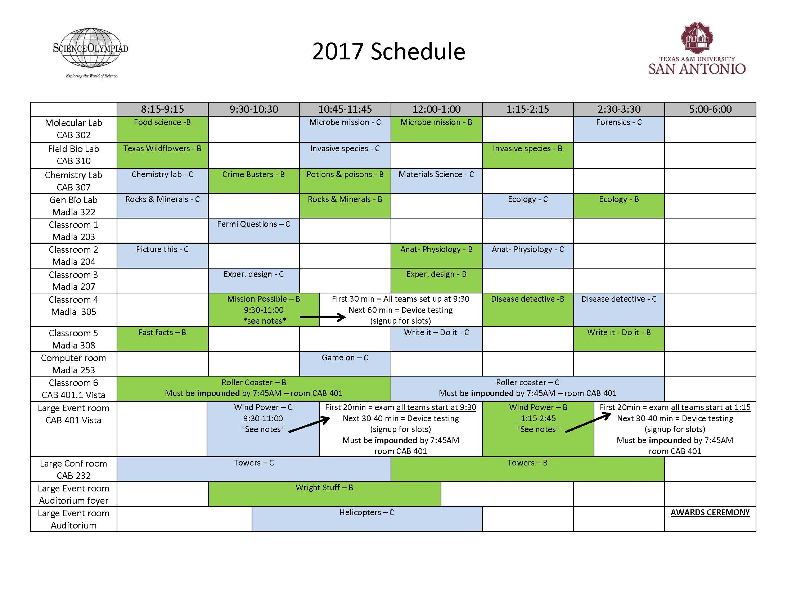

# NORTH

# Madla Building is

EVENTS FIRST FLOOR – CENTRAL ACADEMIC BUILDING

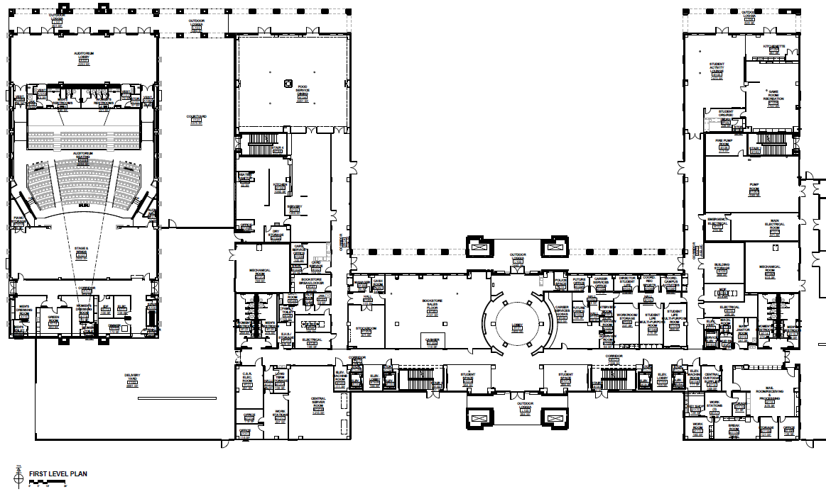

## ROTUNDA

## REGISTRATION

## (Entrance from N or S)

Game Room

In case of rain \***only**\* (team camps)

# TEAM CAMPS

Cafeteria

AWARDS CEREMONY

Helicopters

Wright Stuff

# TEAM CAMPS Under the breezeways (do not block doors) or The central plaza

#### Team Camps

#### Team Camps

#### Team Camps

#### Team Camps

**\*DO NOT SET UP CAMP\*** on the Mosaic University Seal

# TEAM CAMPS

Outdoor tables

Bath-rooms

Bath-rooms

EVENTS 2nd FLOOR – CENTRAL ACADEMIC BUILDING

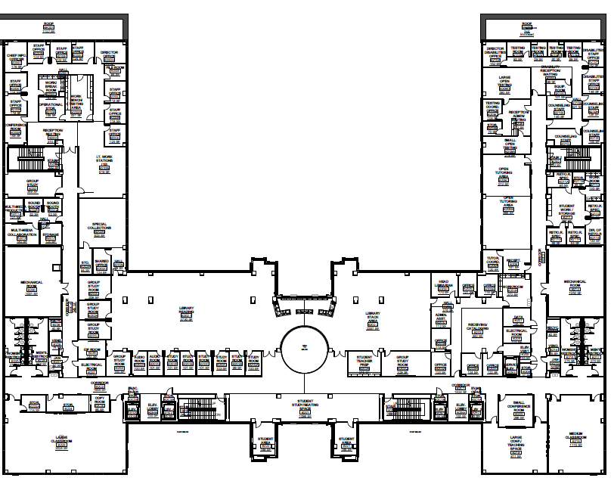

ROOM 232

# Second Floor Events

**Towers B & C**

**\*\*COMPETITORS ONLY\*\***

**\*\*NO LOITERING\*\***

EVENTS 3rd FLOOR – CENTRAL ACADEMIC BUILDING

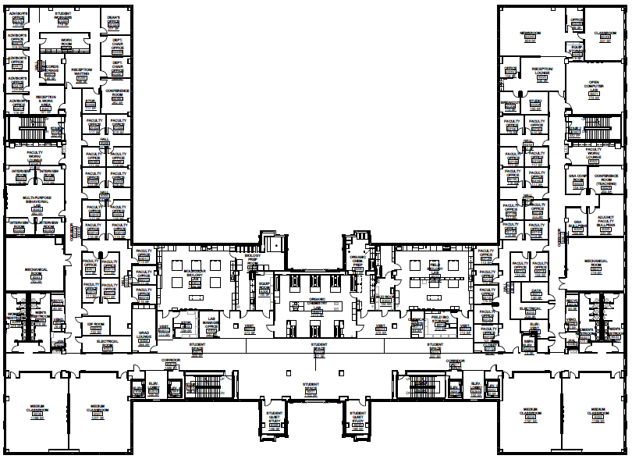

**ROOM 302**

**ROOM 310**

**ROOM 307**

# Third Floor Events

**(302) Food Science – B**

**( 302) Microbe Mission – B/C**

**(302) Forensics - C**

**(307) Chemistry Lab – C**

**(307) Crime Busters – B**

**(307) Potions & Poison – B**

**(307) Materials Science - C**

**(310) Texas Wildflowers – B**

**(310) Invasive Species – B/C**

**\*\*COMPETITORS ONLY\*\***

**\*\*NO LOITERING\*\***

EVENTS 4th FLOOR – CENTRAL ACADEMIC BUILDING

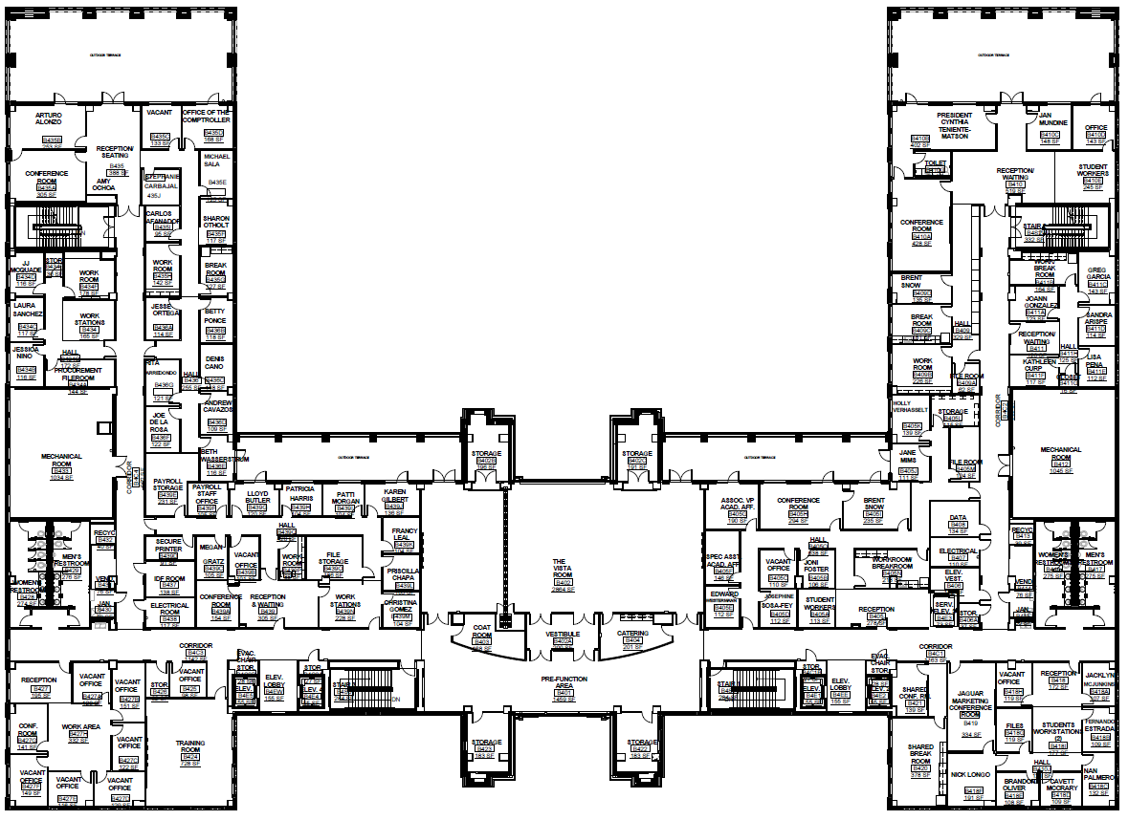

# 4th Floor Events

**(401.1) Roller Coaster B/C**

**(401) Wind Power B/C**

**IMPOUND for both events is located within room 401**

**\*\*MUST BE IMPOUNDED BY 7:45AM\*\***

**\*\*COMPETITORS ONLY\*\***

**\*\*NO LOITERING\*\***

**IMPOUND**

**ROOM 401**

**ROOM 401.1**

EVENTS 1st FLOOR – Madla Building

# NORTH

# Central Academic Building is

# TEAM CAMPS

# Under the breezeways (do not block doors) or the central entry

**NO INDOOR TEAM CAMPS IN THIS BUILDING**



Bath-rooms

Bath-rooms

# TEAM CAMPS

Outdoor tables

# TEAM CAMPS

Outdoor tables

EVENTS 2nd FLOOR – Madla Building



**ROOM 253**

**ROOM 207**

**ROOM 204**

**ROOM 203**

# 2nd Floor Events

**(203) Fermi Questions – C**

**(204) Picture This – C**

**(204) Anatomy-Physiology B/C**

**(207) Experimental Design B/C**

**(253) Game-On- C**

**\*\*COMPETITORS ONLY\*\***

**\*\*NO LOITERING\*\***

EVENTS 3rd FLOOR – Madla Building 

# 3rdFloor Events

**(305) Mission Possible – B**

**(305) Disease Detectives – B/C**

**(308) Fast Facts – B**

**(308) Write-it Do-it B/C**

**(322) Rocks & Minerals B/C**

**(322) Ecology B/C**

**\*\*COMPETITORS ONLY\*\***

**\*\*NO LOITERING\*\***

**ROOM 322**

**ROOM 308**

**ROOM 305**