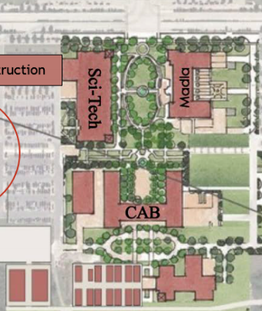

**Auditorium**

Map of campus – showing only relevant areas.

Parking

EVENTS FIRST FLOOR – CENTRAL ACADEMIC BUILDING & AUDITORIUM

# NORTH

**\*\*Note Registration and Check-in in Science & Technology Building**

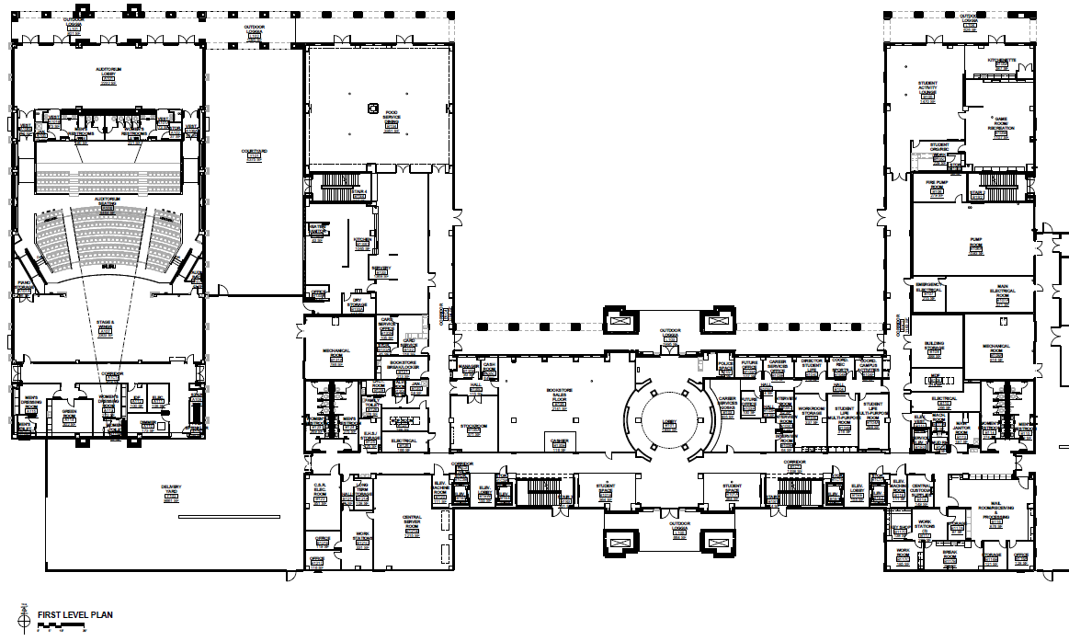

**Stage**

Scrambler C

Wheeled Vehicle

**Foyer**

Flight B/C

AWARDS CEREMONY

#### Team Camps

#### Team Camps

# TEAM CAMPS

Cafeteria

# TEAM CAMPS Under the breezeways (do not block doors) or The central plaza

#### Team Camps

#### Team Camps

#### Team Camps

#### Team Camps

**\*DO NOT SET UP CAMP\*** on the Mosaic University Seal

# TEAM CAMPS

Outdoor tables

Bath-rooms

Bath-rooms

EVENTS 3rd FLOOR – CENTRAL ACADEMIC BUILDING

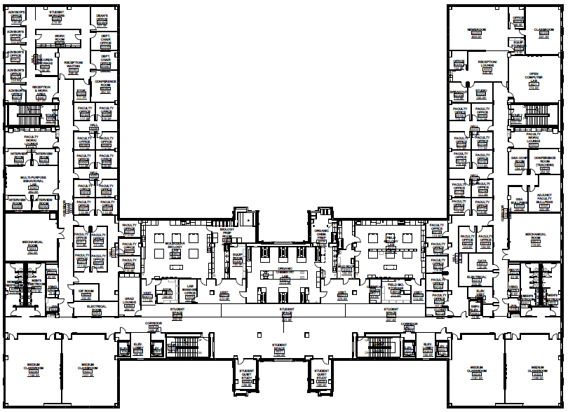

**\*\*COMPETITORS ONLY\*\***

**\*\*NO LOITERING\*\***

**ROOM 302**

Microbe Mission B/C

**ROOM 310**

Forestry B/C

EVENTS 4th FLOOR – CENTRAL ACADEMIC BUILDING

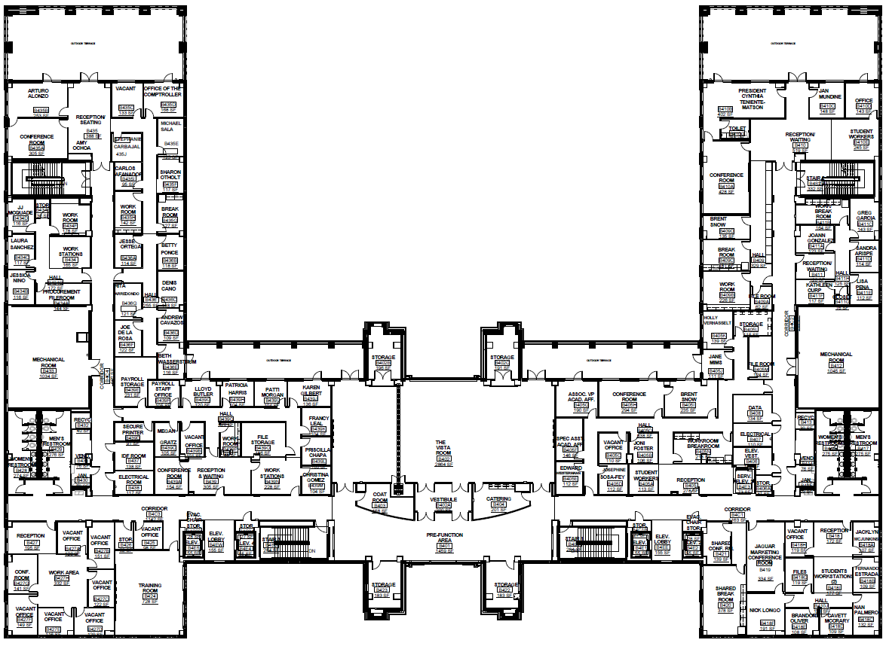

**Vista ROOM 401**

**Air Trajectory B/C**

**Events First Floor – NEW SCIENCE & TECHNOLOGY BUILDING**

N

PARKING LOT

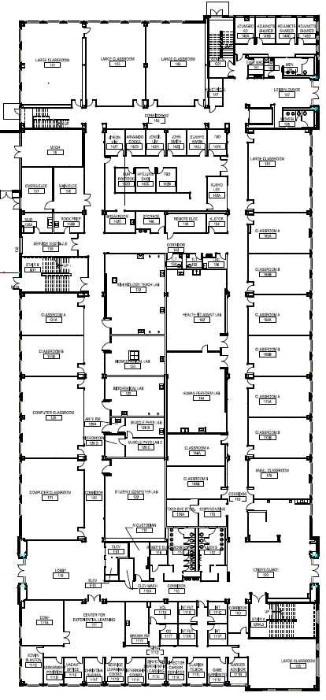

**West Foyer**

Rotor Egg Drop

**Room 165**

Fast Facts B

**Room 169**

Ecology B/C

**Room 166**

Code Busters B/C

**Room 173**

Fermi Questions C

**Room 161**

Meteorology B

Road Scholar B

Astronomy C

**Room 143**

Science Word C

Picture This B

Main Courtyard

Madla

Bathroomsv

Bathroomsv

**Room 141**

Towers B/C

**REGISTRATION & HELP DESK**

TAMUSA Student volunteer room

Bath-rooms

**Events Second Floor – NEW SCIENCE & TECHNOLOGY BUILDING**

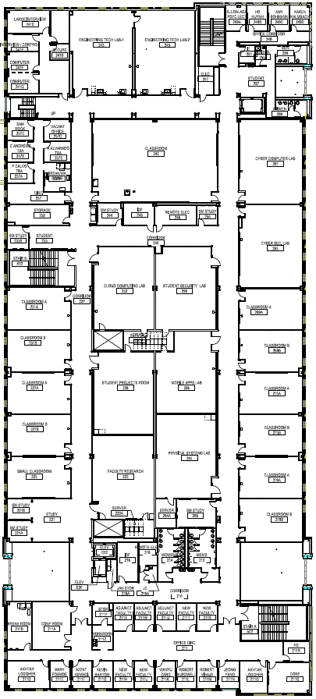

**Room 269**

Roller Coaster B

**Room 231**

Robot C

**Room 261**

Cyber Security C

**Room 261**

Cyber Security C

**Room 261**

Cyber Security C

**Room 273**

Disease Detectives B/C

**Room 279**

We’ve Got Your Number B/C

**Room 242**

Experimental Design B/C

**Room 179**

Mystery Arch.

Picture This

**Room 223**

Designer Genes C

Sounds of Music C

**\*\*COMPETITORS ONLY\*\***

**\*\*NO LOITERING\*\***

**Use bathrooms on 1st floor**

**Events Third Floor – NEW SCIENCE & TECHNOLOGY BUILDING**

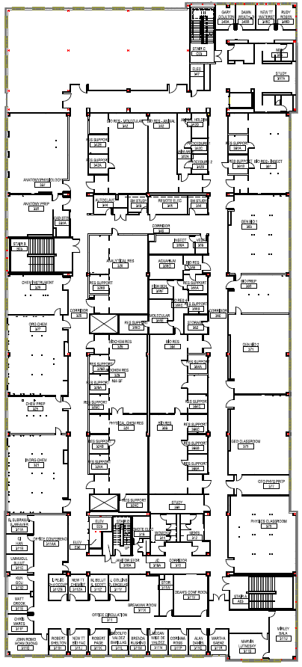

**Room 321**

Can’t Judge a Powder B

Crime Busters B

**Room 327**

Chem Lab C

Forensics C

**Room 311**

Event Coordinator Check-in

SO Director headquarters

**NO TEAM MEMBERS OR COACHES**

**Room 379**

Fossils B/C

**Room 375**

Dynamic Planet B/C

Geologic Mapping C

**Room 371**

Botany B/C

**Room 363**

Write It Do it B/C

**Room 337**

Anatomy-Physiology B/C

**\*\*COMPETITORS ONLY\*\***

**\*\*NO LOITERING\*\***

**Use bathrooms on 1st floor**

Madla Building

# NORTH

# Central Academic Building is



# TEAM CAMPS

# Under the breezeways (do not block doors)

Bath-rooms

Bath-rooms

# TEAM CAMPS

Outdoor tables

# TEAM CAMPS

Outdoor tables