# NORTH

# Madla Building is

EVENTS FIRST FLOOR – CENTRAL ACADEMIC BUILDING

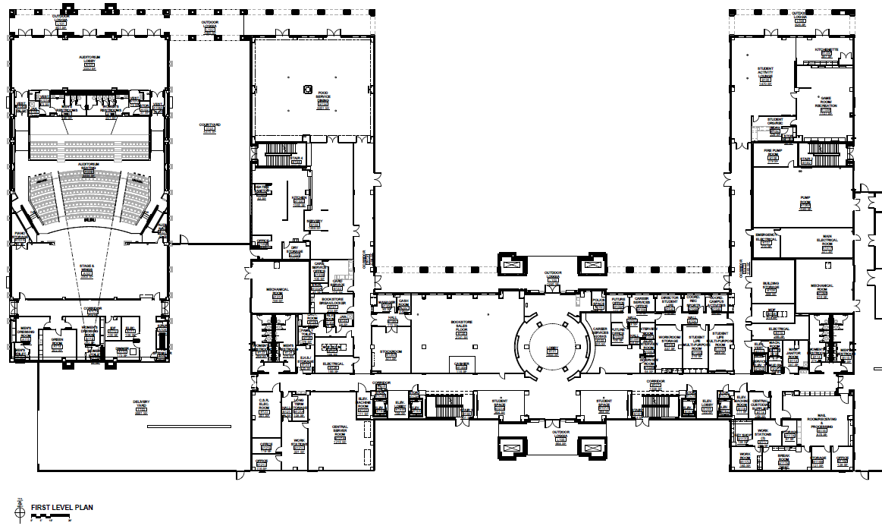

## ROTUNDA

## REGISTRATION

## (entrance from N or S)

Game Room

In case of rain \***only**\* (team camps)

# TEAM CAMPS

Cafeteria

AWARDS CEREMONY

Helicopters

Wright Stuff

# TEAM CAMPS Under the breezeways (do not block doors) or The central plaza

#### Team Camps

#### Team Camps

#### Team Camps

#### Team Camps

**\*DO NOT SET UP CAMP\*** on the Mosaic University Seal

# TEAM CAMPS

Outdoor tables

Bath-rooms

Bath-rooms

EVENTS 2nd FLOOR – CENTRAL ACADEMIC BUILDING

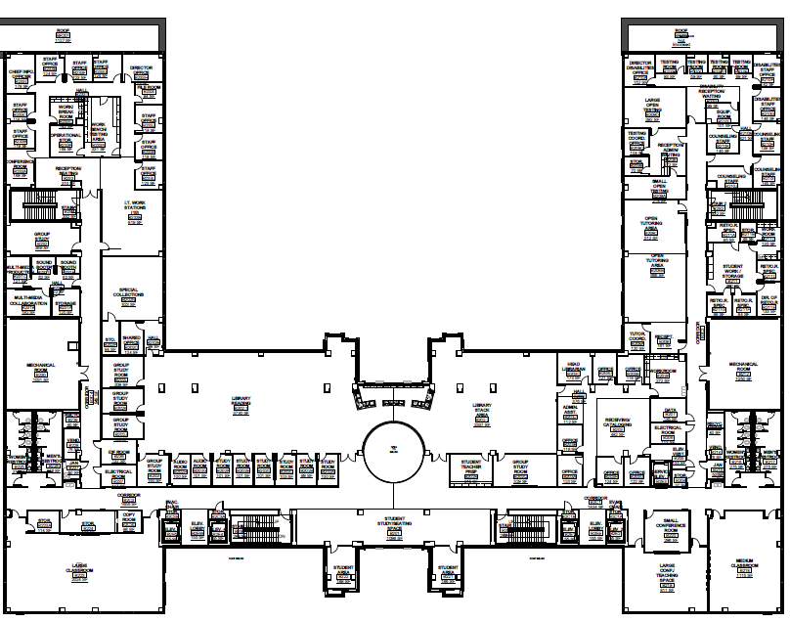

ROOM 232

# Second Floor Events

**Towers B & C**

**\*\*COMPETITORS ONLY\*\***

**\*\*NO LOITERING\*\***

EVENTS 3rd FLOOR – CENTRAL ACADEMIC BUILDING

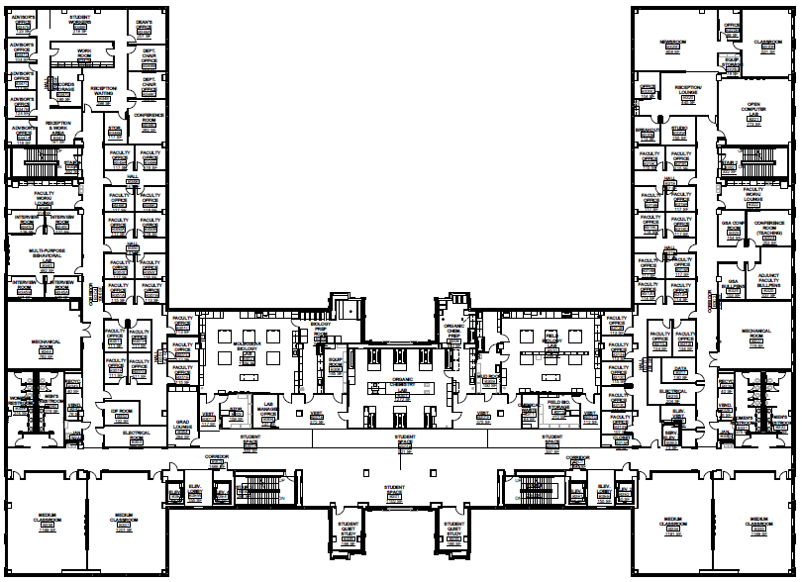

**ROOM 302**

**ROOM 310**

**ROOM 307**

# Third Floor Events

**(302) Food Science – B**

**( 302) Microbe Mission – B/C**

**(302) Forensics - C**

**(307) Chemistry Lab – C**

**(307) Crime Busters – B**

**(307) Potions & Poison – B**

**(307) Materials Science - C**

**(310) Texas Wildflowers – B**

**(310) Invasive Species – B/C**

**\*\*COMPETITORS ONLY\*\***

**\*\*NO LOITERING\*\***

EVENTS 4th FLOOR – CENTRAL ACADEMIC BUILDING

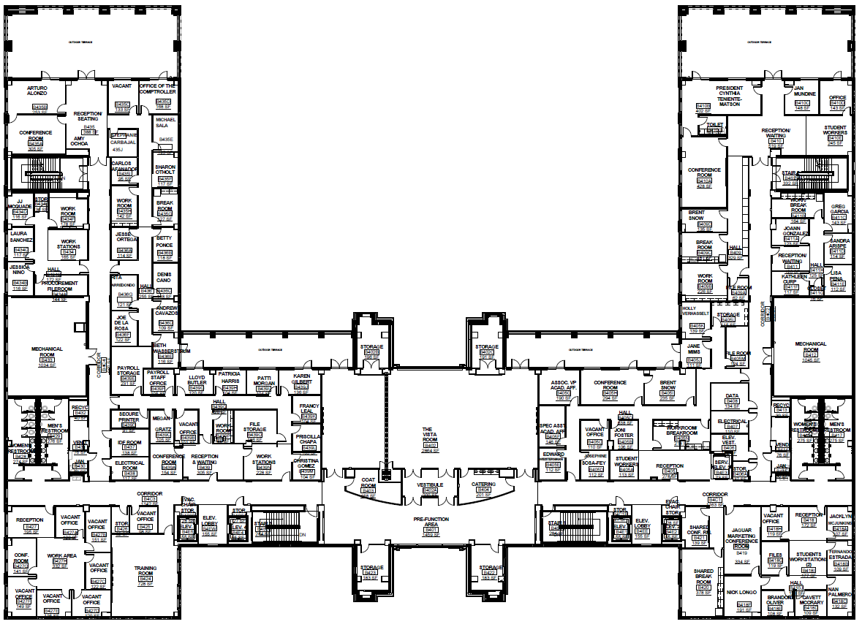

# 4th Floor Events

**(401.1) Roller Coaster B/C**

**(401) Wind Power B/C**

**IMPOUND for both events is located within room 401**

**\*\*MUST BE IMPOUNDED BY 7:45AM\*\***

**\*\*COMPETITORS ONLY\*\***

**\*\*NO LOITERING\*\***

**IMPOUND**

**ROOM 401**

**ROOM 401.1**

EVENTS 1st FLOOR – Madla Building

# NORTH

# Central Academic Building is

# TEAM CAMPS

# Under the breezeways (do not block doors) or the central entry

**NO INDOOR TEAM CAMPS IN THIS BUILDING**



Bath-rooms

Bath-rooms

# TEAM CAMPS

Outdoor tables

# TEAM CAMPS

Outdoor tables

EVENTS 2nd FLOOR – Madla Building



**ROOM 253**

**ROOM 207**

**ROOM 204**

**ROOM 203**

# 2nd Floor Events

**(203) Fermi Questions – C**

**(204) Picture This – C**

**(204) Anatomy-Physiology B/C**

**(207) Experimental Design B/C**

**(253) Game-On- C**

**\*\*COMPETITORS ONLY\*\***

**\*\*NO LOITERING\*\***

EVENTS 3rd FLOOR – Madla Building 

# 3rdFloor Events

**(305) Mission Possible – B**

**(305) Disease Detectives – B/C**

**(308) Fast Facts – B**

**(308) Write-it Do-it B/C**

**(322) Rocks & Minerals B/C**

**(322) Ecology B/C**

**\*\*COMPETITORS ONLY\*\***

**\*\*NO LOITERING\*\***

**ROOM 322**

**ROOM 308**

**ROOM 305**